MSRT Scholarship Golf Classic

__________________________________________________________________________________________
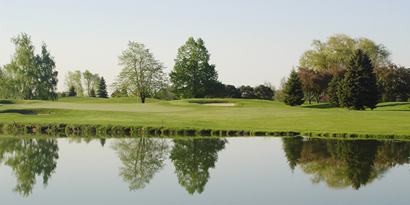

ATTENTION GOLFERS

A Four Person Scramble

“SHOTGUN” START
41st Annual

9AnnaulElmbrook is a US

GA, p

Where business and pleasure come together! Bay Valley Resort features a relaxed lodge atmosphere yet has all the amenities of a fine, quality resort. Enjoy the picturesque views of the lake and golf course from our Royal Troon Ballroom, Heatherfields Restaurant, and Player’s Lounge. Relax in one of our comfortable guest rooms after enjoying a challenging round of golf on our 18 hole championship golf course. Bay Valley’s convenient location, adjacent to I-75 just southwest of Bay City, makes it the perfect stop if you are looking for a getaway or you are just passing through.

ar 72, 18-ho

Tuesday, September 19, 2017 TEE OFF: 9:30am SHARP

“Shotgun” Start ...be at course no later than 8:30am

Come early and you will have free use of driving range until Tee Off

_________________________________________________________________________________________________________________________
BAY VALLEY RESORT, 2470 Old Bridge Rd, Bay City, MI 48706
Cost: $85.00 per person
Includes: 18 holes of golf, power cart, curb-side service, Free driving range balls before 10:00am, Hot dog and hamburg dinner. Trophies and handouts on day of registration. _________________________________________________________________________________________________________________

“SHOTGUN” START
FOURSOMES LISTED BELOW:
SEND CHECKS AND RESERVATIONS PAYABLE TO
MSRT SCHOLARSHIP FUND
RETURN TO:

Kay Williams
1924 Crabtree Lane
Jenison, Michigan 49428

(616) 457-4721

Email Address:
kayw33@hotmail.com

Credit card information

Type: MasterCard_____ Visa_____

Number: _______________________

Name on Card:

________________________________

3-digit number on back: ________

Expiration Date: _______________
Pick your foursome!! (Otherwise we will select for you)

NAME:__________________________________________
ADDRESS:_______________________________________
CITY/STATE/ZIP:__________________________________
PHONE:_________________________________________

NAME:__________________________________________
ADDRESS:_______________________________________
CITY/STATE/ZIP:__________________________________ PHONE:_________________________________________

NAME:__________________________________________
ADDRESS:_______________________________________
CITY/STATE/ZIP:__________________________________
PHONE:_________________________________________

NAME:__________________________________________
ADDRESS:_______________________________________
CITY/STATE/ZIP:__________________________________
PHONE:_____________________________________

